Generating the SAR/Case Review Due Date Report

Knowledge Base Article

Table of Contents

Overview 3
Navigating to the Report 3
Generating the Report 5
Applying Excel Filters to the Visitation Details 7

Overview
The SAR/Case Review Due Date Report is a planning tool that assists caseworkers and supervisors in scheduling SARs and Case Reviews within the required timeframes.

Ohio SACWIS staff has worked closely with Monitoring and Policy staff to ensure that the SAR/Case Review Due Dates are accurately calculated according to the requirements.

According to Case Review and SAR rule requirements, which are outlined in 5101:2-3809 and 5101:2-38-10, whichever of the following activities occurs first begins the Case Review/SAR timeline:
- The original court complaint date
- The date of placement
- The date of court order protective supervision
- The date of parent, guardian, or custodian’s signature on the case plan, for in home supportive services only.

Case Reviews are due every 90 Days from the date of the originating activity. SARs are due every 180 Days from the date of the originating activity.

Navigating to the Report

- From the Ohio SACWIS Home screen, click the Administration tab.
- Click the Reports tab.
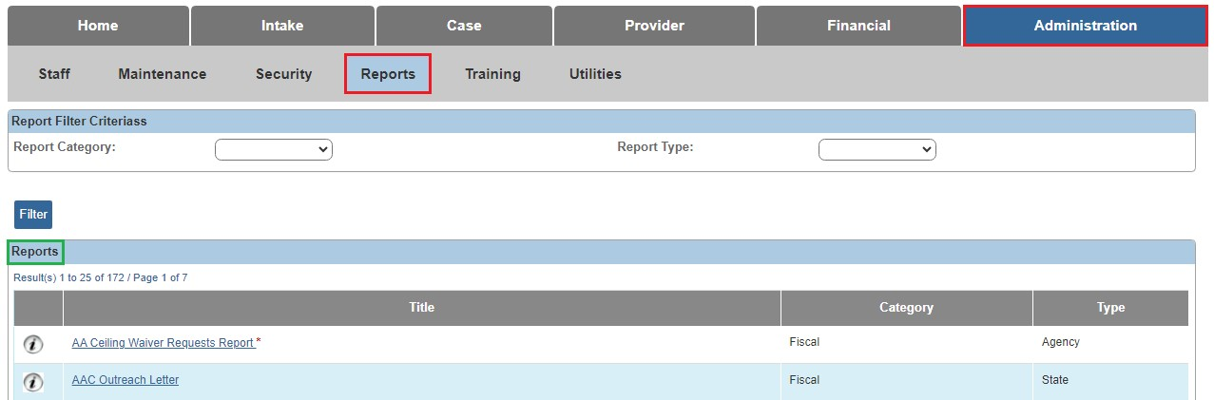

The Reports Filter Criteria screen appears.
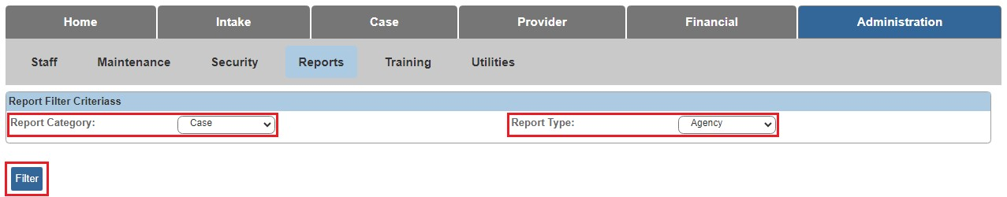

- Select Case from the Report Category dropdown.
- Select Agency from the Report Type dropdown.

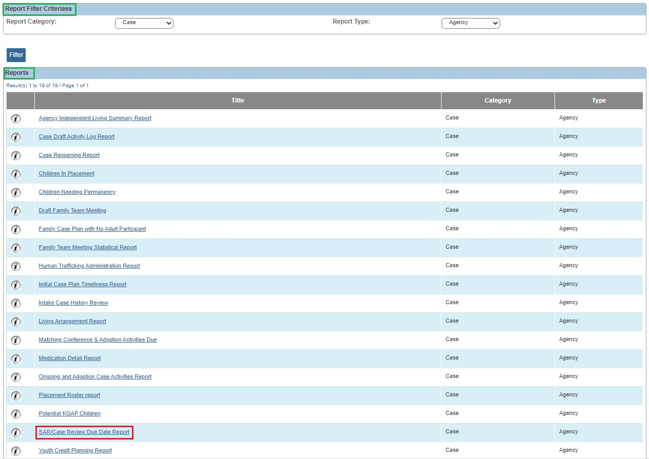

- Click the SAR/Case Review Due Date Report link.

The Report Details screen appears.

Generating the Report

- Select the Report Output Format (PDF or Excel).
- Click the Generate Report button.

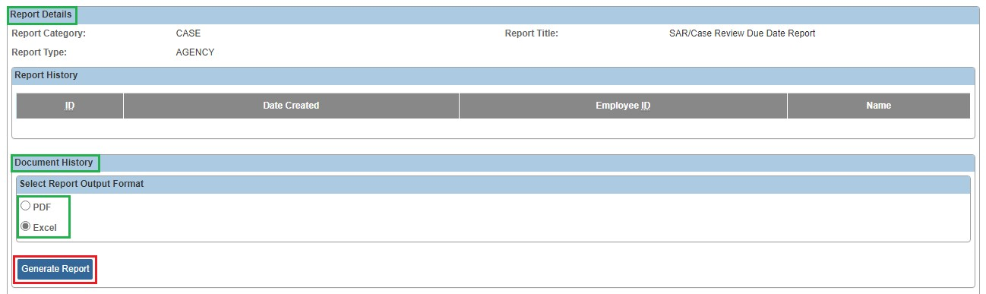

The SAR/Case Review Due Date Report parameter page appears.
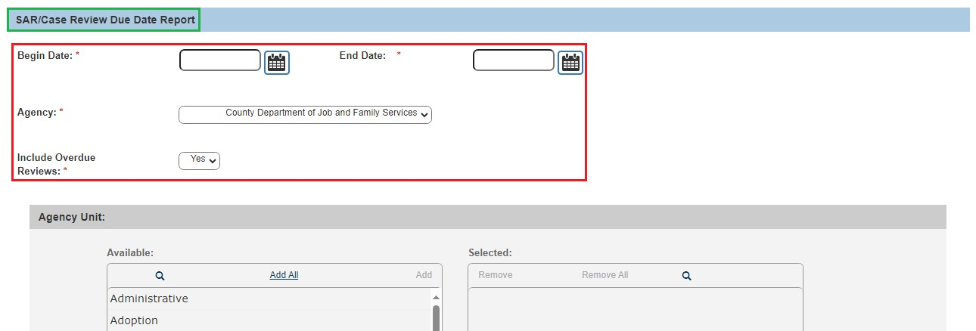

- Enter the Begin Date (Required)
- Enter the End Date (Required)
- Select the Agency (Required)
- Select Yes or No for Include Overdue Reviews (Required)
Note: County users will only be able to generate the report for their own agency. State users will be able to select multiple agencies.
- Use the Add> and <Remove buttons to select the Agency Unit(s), if necessary.
- Use the Add> and <Remove buttons to select the Supervisor(s), if necessary.
- Use the Add> and <Remove buttons to select the Worker(s), if necessary.
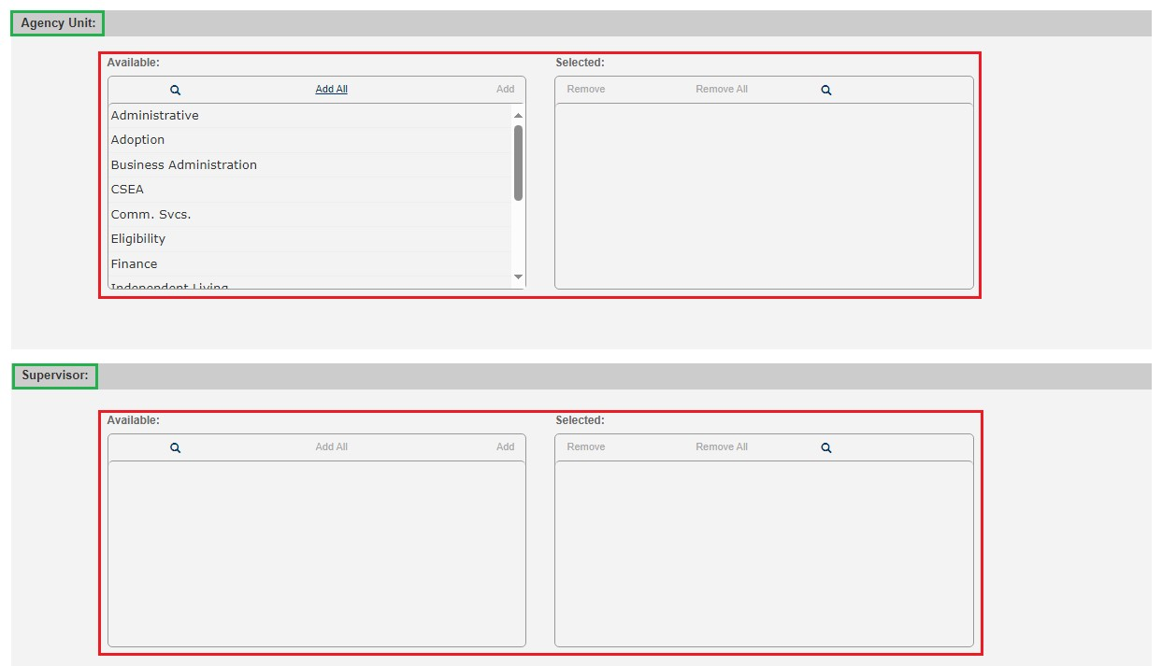
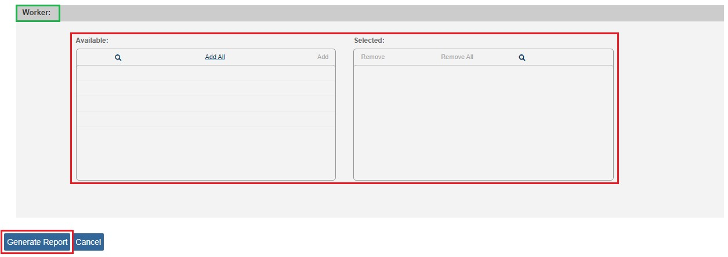
- Click the Generate Report button.

A message appears stating your report is being created.
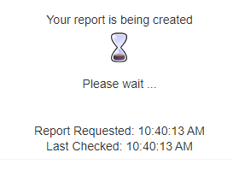
The Report Confirmation screen appears when the report has run successfully.

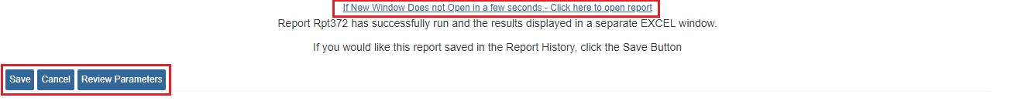

- If the report does not open, select the Click here to open report link.

- Click the Save button in order to save the generated report to the Report History.

- Select Review Parameters to return to the Report Parameters screen.

The SAR/Case Review Due Report appears in excel format (suggested).

Applying Excel Filters to the Visitation Details

- Select the Row that containing the data element Column Headers.
Hint: Place your cursor on the Row Number to highlight the row.
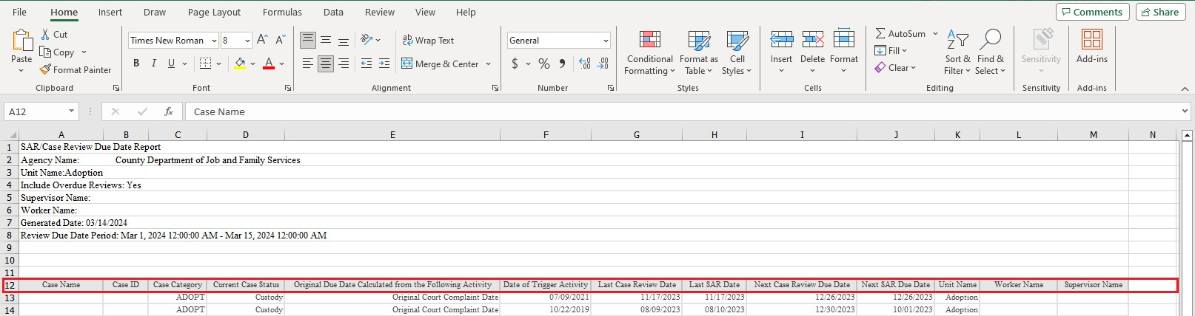
- From the Home tab, once the row is highlighted, click the Sort & Filter button.
- Select Filter.

Drop down Filter Arrows will appear on each cell in the highlighted Row.

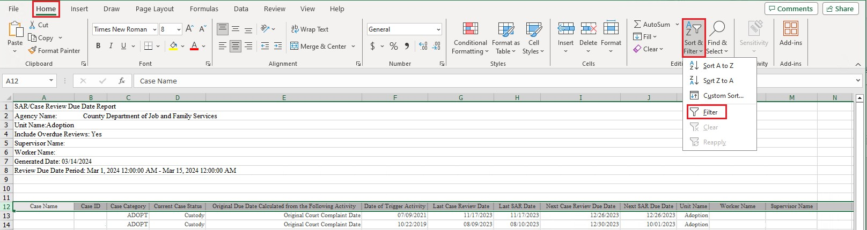

- Click the Filter Arrow for the Column you wish to filter.

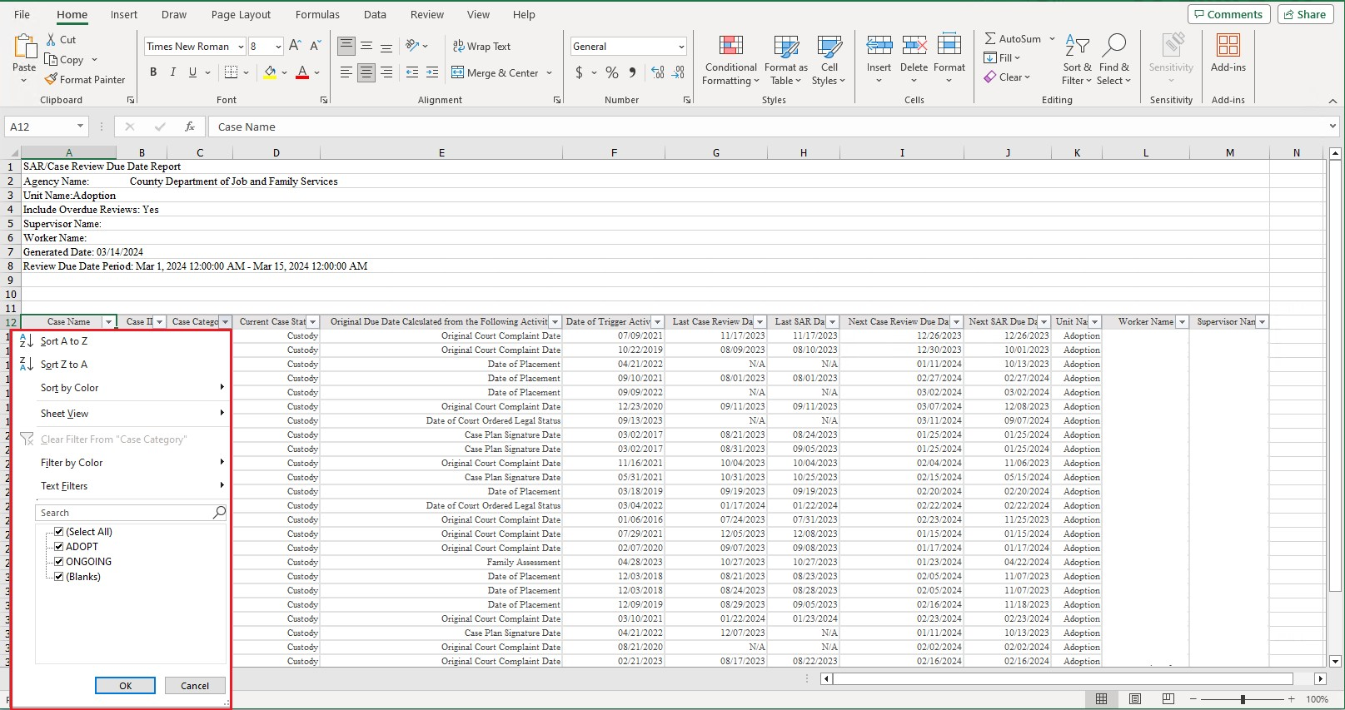

If you need additional information or assistance, please contact the OFC Automated Systems Help Desk at sacwis_help_desk@childrenandyouth.ohio.gov .

